**GitLab Installation on RHEL8**

Across all operating systems, GitLab has two distinct products:

* GitLab Community Edition (CE) – Free to use
* GitLab Enterprise Edition (EE) – Requires purchased license to use.

We have installed CE version.

**Step 1: Update system and Install Dependencies**

sudo yum -y update

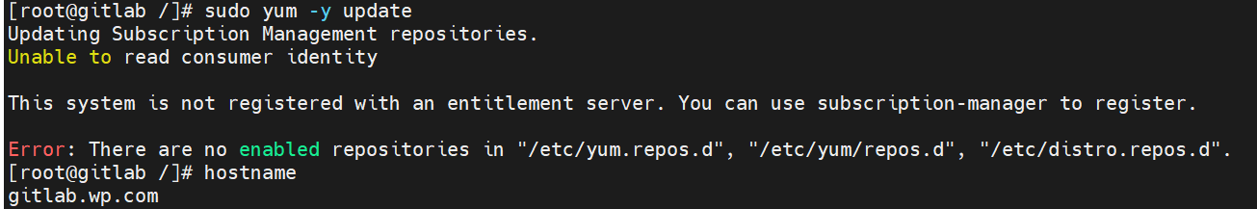

If there is no enabled repository then you need to configure yum repository.

Now run:

sudo yum -y install curl vim policycoreutils python3-policycoreutils

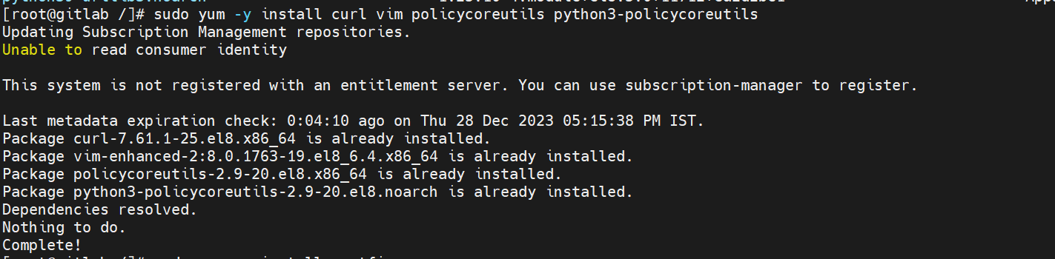

If you want to install and use local mail server for sending notifications, then install Postfix:

Start and enable Postfix service after the installation.



**Step 2: Add the Gitlab CE Repository**

curl -s https://packages.gitlab.com/install/repositories/gitlab/gitlab-ce/script.rpm.sh | sudo bash

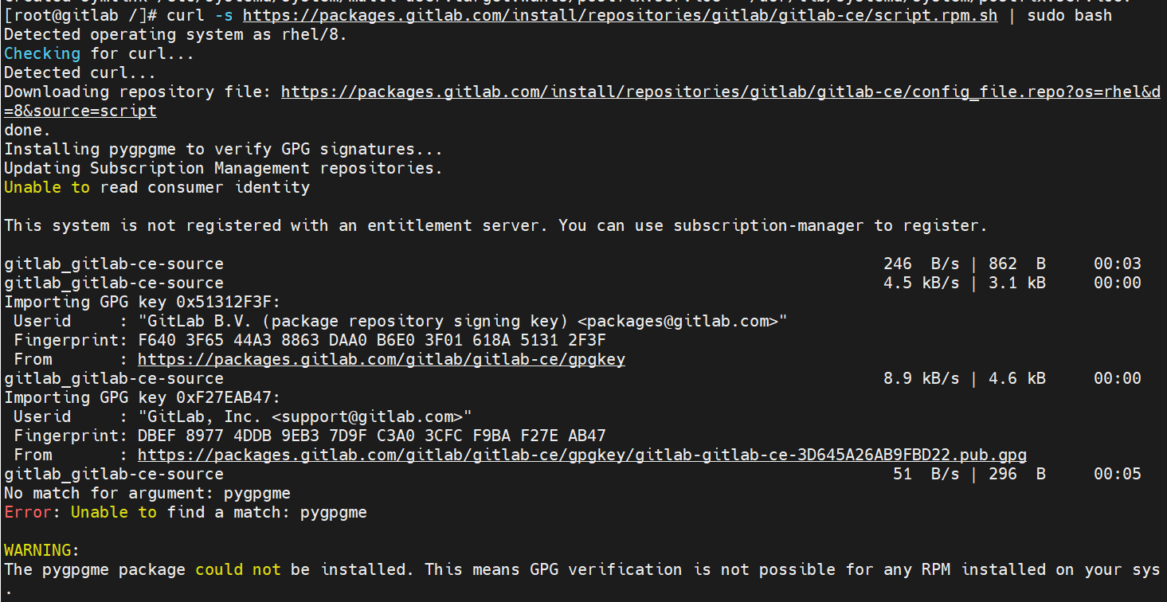

If you find the error of unable to find a match pygpme:   
you need to install the alternative package for pygpme named as **varnish**

If the script execution is successful, you’ll get output similar to below.

**The repository is setup! You can now install packages.**

**Step 3: Install GitLab CE from Repo**

Install GitLab CE by running the command:

sudo yum install gitlab-ce

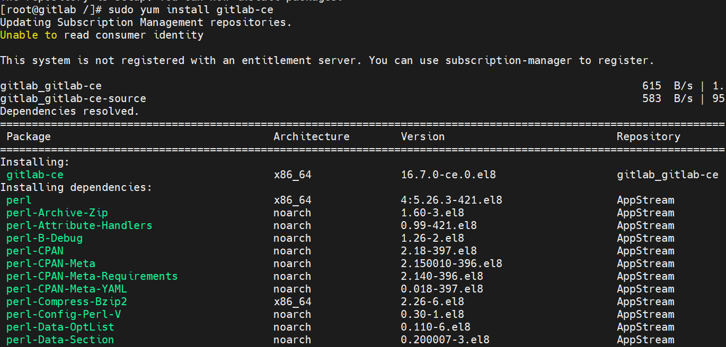

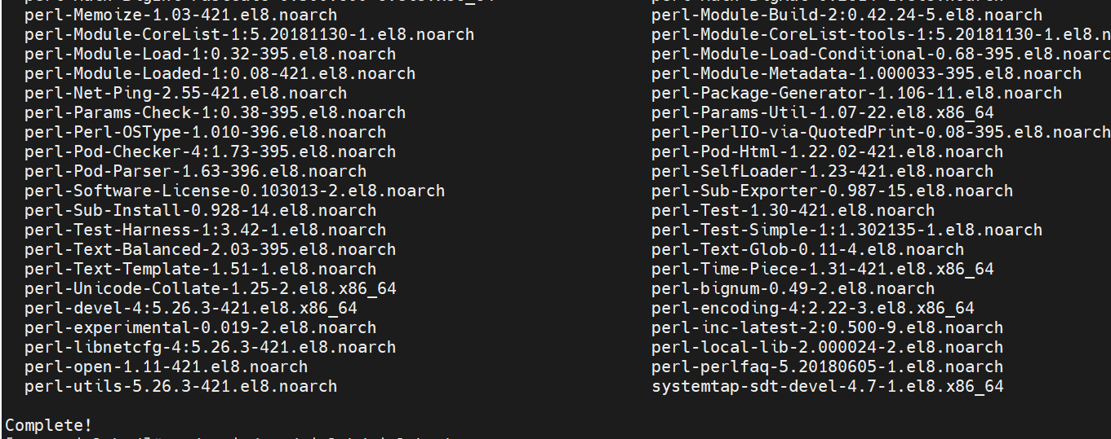

**Step 4: Configure GitLab CE Server**

Our installation is done, we can then do the GitLab configuration that works for our environment. The main configuration file for GitLab is located under */etc/gitlab/gitlab.rb*.

sudo vi /etc/gitlab/gitlab.rb

E.g, Set URL on which GitLab will be reachable:

In our env external URL is: **http://gitlab.wp.com**

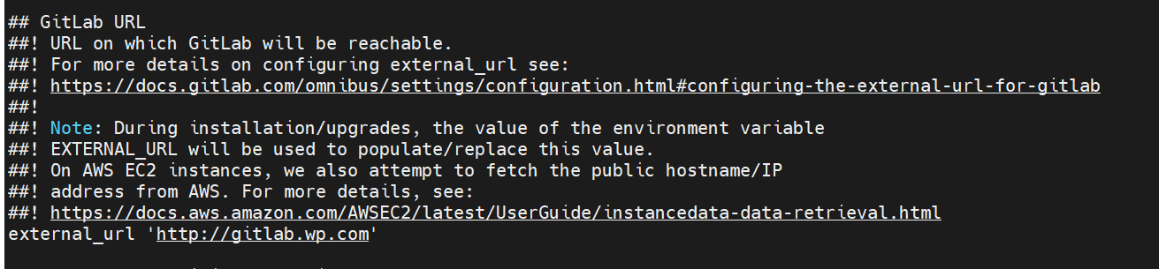

Save the gitlab.rb file and run the below command to reconfigure  
sudo gitlab-ctl reconfigure

You will get the below output if the script is successful.

If you have an active firewall, allow http, https and ssh services.

sudo firewall-cmd --permanent --add-service={ssh,http,https} --permanent

sudo firewall-cmd --reload

**Step 5: Access GitLab Web Console**

Open your browser and go to URL [**http://gitlab.example.com**](https://computingforgeeks.com/) to finish the installation of Gitlab.

Defaults user is root and password you will find in /etc/gitlab/initial_root_password

Gitlab is installed!!!

**To push data to existing repo:**

cd existing_repo

git remote add origin http://gitlab.wp.com/root/test.git

git branch -M main

git push -uf origin main